Pacman Game using Object-Oriented Programming

Project Report

1. Introduction
This project implements a console-based Pacman game using Object-Oriented Programming (OOP) concepts. The game consists of multiple interacting classes including Pacman, Ghost, GameBoard, Food, and Pacman_Game. The player controls Pacman using keyboard inputs and collects food items while avoiding the ghost. The game ends when either all food is eaten (win condition) or the ghost catches Pacman (lose condition).
The project demonstrates core OOP principles such as encapsulation, abstraction, object interaction, and modular design.

2. Objectives
- To implement a Pacman game using OOP concepts
- To practice class interaction and object communication
- To implement game loop logic
- To handle user input and movement
- To implement scoring system
- To demonstrate encapsulation and modular programming

3. Classes Used in Project
The project consists of the following classes:
- Pacman_Game (Main class)
- Game_board
- Pacman
- Ghost
- Food
Each class has a specific responsibility in the game.

4. Pacman_Game Class (Main Class)
This class contains the main method and controls the game execution. It initializes all objects and runs the game loop.
Responsibilities:
- Create game objects
- Handle user input
- Display game board
- Check win condition
- Check lose condition
- Control game loop
Objects created:
- Game_board board
- Pacman player
- Food food
- Ghost ghost
Game Loop Steps:
- Display board
- Show score
- Take user input
- Move Pacman
- Check win condition
- Check collision with ghost
- Move ghost
- Check collision again

5. Pacman Class
This class represents the player character Pacman.
Attributes:
- row → current row position
- column → current column position
- score → player score
Methods:
- move() → moves pacman based on input
- get_row() → returns row position
- get_column() → returns column position
- get_score() → returns score
Functionality:
- Takes movement input (W/A/S/D)
- Checks wall collision
- Updates position
- Eats food
- Updates score
Score System:
- Each food eaten = +10 points

6. Game_board Class
This class represents the game map.
Attributes:
- 2D char array board
Symbols Used:
- # → wall
- . → food
- P → pacman
- G → ghost
- space → empty
Methods:
- display_board() → prints game board
- is_wall() → checks wall
- has_food() → checks food
- remove_food() → removes food
- food_remaining() → checks remaining food
This class controls:
- Game layout
- Board display
- Wall detection
- Food placement

7. Food Class
This class manages food count.
Attribute:
- totalFood → total food count
Methods:
- countFood() → counts food initially
- eatFood() → decreases food count
- allFoodEaten() → checks win condition
- getRemainingFood() → remaining food
This class separates food logic from board logic.

8. Ghost Class
This class represents the enemy ghost.
Attributes:
- row → ghost row position
- column → ghost column position
Methods:
- move() → random movement
- get_row() → return row
- get_column() → return column
- hitsPacman() → collision detection
Ghost Movement:
- Random direction
- Cannot pass through walls
- Moves after player turn

9. OOP Concepts Used
Encapsulation
Each class hides its data using private variables.
Example:
- Pacman position is private
- Ghost position is private
- Food count is private
Abstraction
Each class handles its own responsibility.
Example:
- Game_board handles board logic
- Pacman handles movement
- Ghost handles enemy behaviour
- Food handles food counting
Object Interaction
Classes communicate with each other.
Example:
- Pacman interacts with Game_board
- Pacman interacts with Food
- Ghost interacts with Pacman
- Main class controls all objects
Modularity
Code is divided into separate classes for readability and reuse.

10. Game Controls
Key | Movement
W | Move Up
S | Move Down
A | Move Left
D | Move Right

11. Game Rules
- Player controls Pacman
- Pacman eats food (.)
- Each food = 10 points
- Ghost moves randomly
- If ghost touches Pacman → Game Over
- If all food eaten → Player Wins

12. Sample Output
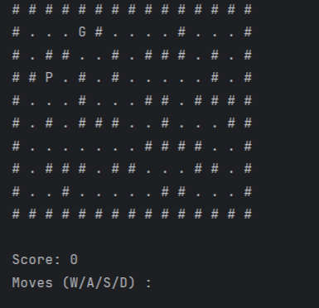

13. Conclusion
The Pacman game was successfully implemented using Object-Oriented Programming principles. Multiple classes were used to represent different components of the game. The project demonstrates class interaction, encapsulation, modular design, and game loop logic. This project improves understanding of OOP concepts and game development fundamentals.

14. Future Improvements
- Multiple ghosts
- Levels system
- GUI version
- Power pellets
- Ghost AI chasing player
- Timer system
- High score system

